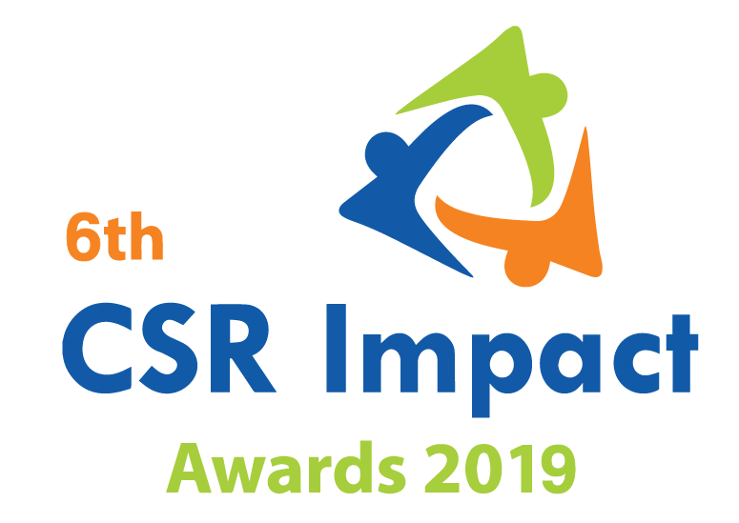
For Companies only |  | Small
 |  | Large

India CSR Summit & Exhibition 2019
6th CSR Impact Awards 2019-Application Form (Category 10 only)

Please select the Category (Only one category/each form, for more than one category submit separate form and read the guidelines)
1 | Healthcare | ***
2 | Education | ***
3 | Skills Development | ***
4 | Livelihoods | ***
5 | Environment | ***
6 | WASH (Water, Sanitation and Hygiene) | ***
7 | Women Empowerment | ***
8 | Rural Development and Infrastructure | ***
9 | Special Categories (Old Age, Specially-abled and others) | ***
10 | Employee Volunteering Initiative
11 | CSR Project of the Year 2018-19 | ***
 | Special Award | ***
12 | CSR Foundation of the Year 2018-19 (only for CSR Foundation) | ***
13 | Company with Best CSR Impacts (2018-19) Only for companies | ***
14 | CSR Implementing Agency of the Year 2018-19 (For implementing agency only) | ***

(Please read the award-guidelines carefully before submitting this form)
Please send filled in form and application fee to the address below and email a copy to csrimpactawards@gmail.com

NGOBOX (Renalysis Consultants Pvt Ltd)
B-1005, Titanium Heights, Opp. Vodafone House, Corporate Road, Prahalad Nagar,
Ahmedabad 380051 (Gujarat)
Call +91-9560352170/ +91-9971429654

Note: This category does not have any specific criteria for the assessment. Even though quality of volunteering work, selection of partners/initiatives and options available to an employee for volunteering will have more focus during the assessment/evaluation). The screening team and jury may develop specific criteria for the qualitative evaluation.

Please provide the application fee information here
Application Fee: INR
Paid vide Cheque/DD/NEFT:
Date:
Comment:

Date: Location:

Part A: Organizational Profile

A1 | Name of the organization applying for the Award (Full Name) (Please do not use acronym)
A2 | Office Address | Address:  Contact No.
A3 | Contact Person for this application (This will be the nodal contact point for this application) | Name:  Designation:  Mobile:  Email:  Alternate Contact no.
A4 | Organization website
A5 | Type of organization | Company  CSR Foundation/Trust  NGO/Section 25/Section 8 Company
A6 | Name of the CEO/President/Director
A7 | By submitting this application form, the organization agrees to provide all the project related information during the assessment process and will abide by the rules set by the organizers. The applicant also acknowledges that all the information provided in this application form is correct.
 | Seal, Name and Signature of Authorized Representative

Part B: Project Details

B1 | Title of the project
B2 | Project geography (Specify details like state, district, blocks etc)
B3 | Total no. of beneficiaries the project intended to reach
B4 | Total no. of beneficiaries that the project could reach
B5 | Name of the company/companies which has/have given support through Employee Volunteering
B6 | Which are the other partners/institutional engagements in the project? (name of implementing Partners, NGOs, Community bodies etc)
B7 | When did the project start and when does it intend to end/ended | Start date:  End date:
B8 | Financial Information | Was there any financial contribution/matching grant or other similar mecahnsim in Employee Volunteering Initiative? Please provide details.

Part C: Project Summary (Maximum 800 words)

Part D: Project Details

D1: Basic Information

Please give company’s headquarter/Corporate office City name
Provide details of the total plants/factories/Regional offices (major cost and production centres) in case of factories, please specify location.
How many employees volunteered in FY 2018-19 and what percentage of the total employees of the company?
Total number of employees in organization as on 31st March 2018
How many hours of contribution was made in volunteering in FY 2018-19
Was the volunteering majorly done during working hours?
Did employee volunteer during weekends/holidays as well?
Who coordinates with employees and organizations with whom employees volunteer? | - Human Resources Department  - CSR Team/Department  - PR/Communication Team
Who all from the top five executives (management) of the company volunteer for a cause in FY 2018-19? Please provide brief information.
Is employee volunteering a part of employee performance assessment?
Is there any maximum limit of time/Hours that an employee can go for volunteering in a month/Year? Please provide details?
Does your organization have a policy/guidelines/Manual on employee volunteering? If yes, please provide a summary of the same? (Max. 400 words)

D2: Volunteering Information

D2.1: What were the causes/initiatives for which your employees volunteered in FY 2018-19?
D2.2: Enlist NGO/Civil Society/Local Partner for employee volunteering and Locations in FY 2018-19?

D2.3: How do you select a cause and partners for volunteering? (Max.250 words)

D2.4: How many beneficiaries did your employee reach out to in FY 2018-19 or how did their volunteering made impacts/difference to the cause? Please give initiative-wise information? (Max. 150 words for each cause/campaign)

D2.5: What type of major volunteering it was? Technical support in line with employees’ professional background or general volunteering as per the requirement of the partner organization/campaign.? Please elaborate (Max. 300 words)

D2.6: What are the major inputs/concerns/learning among employees after volunteering with NGOs/for a cause/campaign? (Please mention experiences shared by your employees and assessment done by any of your department)

Annexure
- Please add appropriate annexure like tables, images, diagrams, media-reports, and web-links). In case you wish to submit a Powerpoint presentation for the project, please send the same along with the application. The maximum number of slides: 10)
- In case you wish to enclose a report or any other documentary proof, please send the same along with the hard copy of the application form and mention the same here.
__***___

